ERT Run-through
Link to the data set I used on Google Drive (You’ll need this):
https://drive.google.com/drive/folders/1-rwbodUKEP1IyQFb4aR_SFE0_zGgM_bQ?usp=sharing

- If you download the FacialData folder from my GDrive using the link above and save it in your root folder on GDrive then you can run the test yourself to see how this emotion recognition project works.
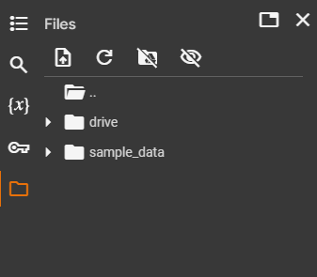
- If you open the Google Collab project from my portfolio site there is a folder icon on the left toolbar. Click this and it will expand. There should be something that looks like this:
- Beneath the ‘Files’ title, there are four icons. Click on the third which will ask if you want to mount your GDrive to Google Collab for the session. Select this option and wait. The folder ‘drive’ should pop up below as in the image above. The file paths in the code blocks are set up for ‘/content/drive/MyDrive/FacialData/’ and so when you upload your copy of the ‘FacialData’ folder to your GDrive, make sure that it is in the root folder or this will not work.
If you click to expand ‘drive,’ you will see ‘MyDrive.’ Inside this you should have FacialData listed. If not then it is in the wrong place and should be moved to this level for this to work.
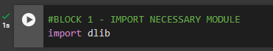
- On the right, we have all the code for this project to work. I have named each ‘Block’ followed by ascending numbers. Block 1 is for importing the necessary module for machine learning and data analysis, dlib. You will see the run cell button to the left of the block. Click this to run.
You will see a green tick if it was successful.
- Run block 2. This will find and download the face detection model we will use for predicting emotions in images.
- Run block 3. This prepares the face detector and shape predictor for locating facial structures and feature extraction.
- Run block 4. This will give us a visual example of the facial structure being detected but also the landmark features found will be marked for us to see. Once successfully run, the result will be displayed just below the block 4 code. Take note that the emotion label of the image has been outputted along with a set of numbers. There are 68 features and so we have 136 numbers pertaining to the x, y coordinates of each feature.
- Ignore block 5.
- Run block 6. This is how we prepare the model for exposure to the data. It will run through the entire Training set where we tell it the emotion label and it will extract the features on each detected face. This ensures that it can gauge the underlying patterns for each face.
if you look in the file directory on the left, there will be a file called ‘all_annotations.csv.’ Double clicking will open it on the right hand side so you can see the data.
- Run block 7. This will suppress some warnings we do not want.
- Run block 8. This may take a minute for the file to show up but it will. This block will create a new csv file with the data from ‘all_annotations’ but it will also add in a new row called emotions followed by numbered headings for each feature.
- Ignore block 9, 10, 11, and 12.
- We are now interested in block 13, 14, and 15 where the actual magic happens.
Run block 13. It will write a new csv file which will be what exposes the model to the Training set. Here we are actually extracting facial landmarks such as the eyes and mouth using the shape detection functionality you seen a visual of earlier. The extracted 68 features can be used to calculate landmarks on a face. The file will be called, ‘extra_annotations_features.csv’ which you can look at. As the code is running, you can see beneath the block what the output is. We are looking for 8 features that correspond to different parts of the face i.e. upper lip, left eyebrow, left eye etc. These values are what will be used when we expose the model to unseen data.
- Once this has run successfully, run block 14.
- Run block 15. This is where we get the model to predict based on unseen data, aka the Validation set.
This can take up to 10 minutes because there are thousands of images to process. There will be an output at the bottom of the code block to give you results such as total predictions made, correct predictions, accuracy and images no discernible features were found. This accuracy will always be the same or should be unless using a new set of data, but you can run it again and see.

Hopefully that worked for you and didn’t take long. Email me if there are any problems and I will do my best to improve this. It isn’t essential to get this working, but I think it’s interesting to see how someone learns and implements code, especially on something being the first attempt. Please read over my code and get in touch if me on LinkedIn or by email with any thoughts or if you would simply like to connect. Look forward to being in touch 😊

